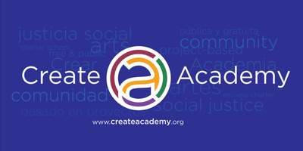
Governing Board Retreat
Saturday, July 28, 2018
8:30 a.m. to 5:00 p.m.

Create Academy
2645 North 24th Street
Phoenix, Arizona 85008

8:30 a.m. - 9:30 a.m. CALIBRATE – To adjust or mark
Johnny
- Icebreaker/Update/Purpose
- Self-assessment and open discussion – worksheet used
- Board Governance & You – video & informational sheet

9:30 a.m. - 10:45 a.m. CULTIVATE – Try to acquire or develop
Victor/Johnny
- Open meeting law - video
- Robert’s rules of order
- Creating go forward standards for Create Governing Board meetings – group project
- Onboarding new board members – group project to establish protocol & formal process

10:45 a.m. - 11:00 a.m. BREAK

11:00 a.m. - 1:00 p.m. COMMITMENT – Dedicated to a cause
Angela/Johnny/Jake
- Governing board commitments – document review and adoption
- New board committee structure
- Governing ourselves & bylaws review – establishing a guide for review and updating
- BoardOnTrack presentation
- Review/establish board calendar

1:00 p.m. - 1:45 p.m. LUNCH

1:45 p.m. - 4:30 p.m. COLLABORATE – Work jointly on an activity
Kelly/Johnny/Angela
- Strategic planning
  - Breakout sessions
  - Establishing goals
  - Living the mission
- CEO evaluation project

4:30 p.m. – 4:45 p.m. BREAK

4:45 p.m. - 5:00 p.m. CELEBRATE – Acknowledge with a social gathering or activity
Johnny/Kelly/Angela
- Review facility construction progress
- Update on enrollment
- Closing remarks / key take-a-ways
- Feedback survey

